CSA1708-ARTIFICIAL INTELLIGENCE
LAB EXPERIMENTS

Program 5: write the python program for missionaries cannibal problem
Aim:
To write a Python program to solve the Missionaries and Cannibals Problem using the Breadth-First Search (BFS) algorithm.
Algorithm:
- Start the program.
- Initialize three missionaries and three cannibals on the left bank, with the boat on the left bank.
- Define the possible boat movements: one missionary, two missionaries, one cannibal, two cannibals, or one missionary and one cannibal.
- Use a queue to explore possible states using BFS.
- Check that no bank has more cannibals than missionaries when missionaries are present.
- Reject invalid states and avoid revisiting states.
- Continue until all missionaries and cannibals reach the right bank.
- Print the solution path.
- Stop the program.
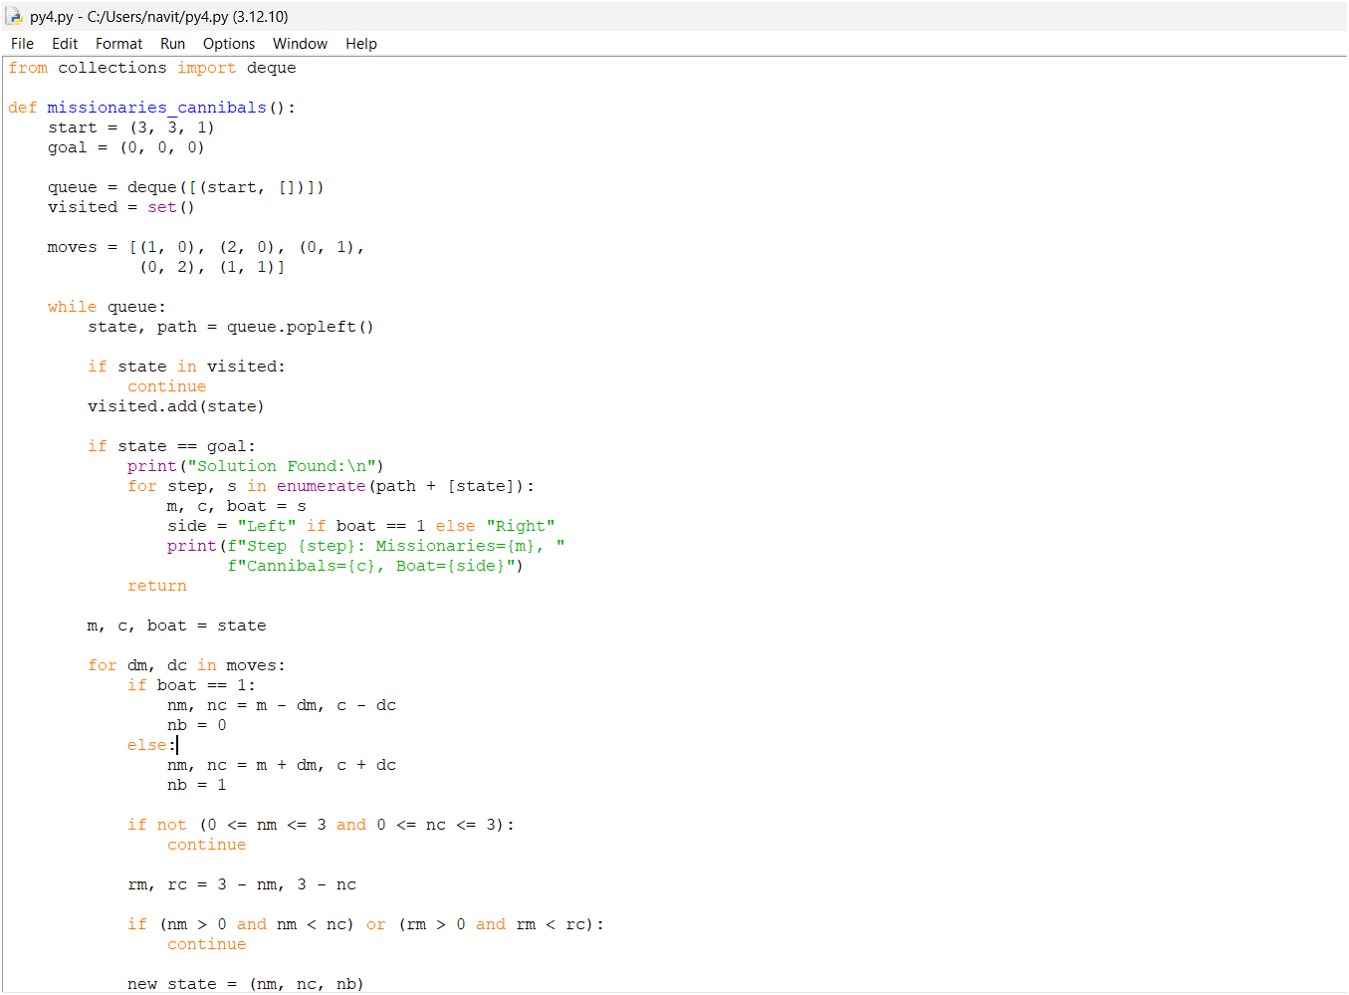
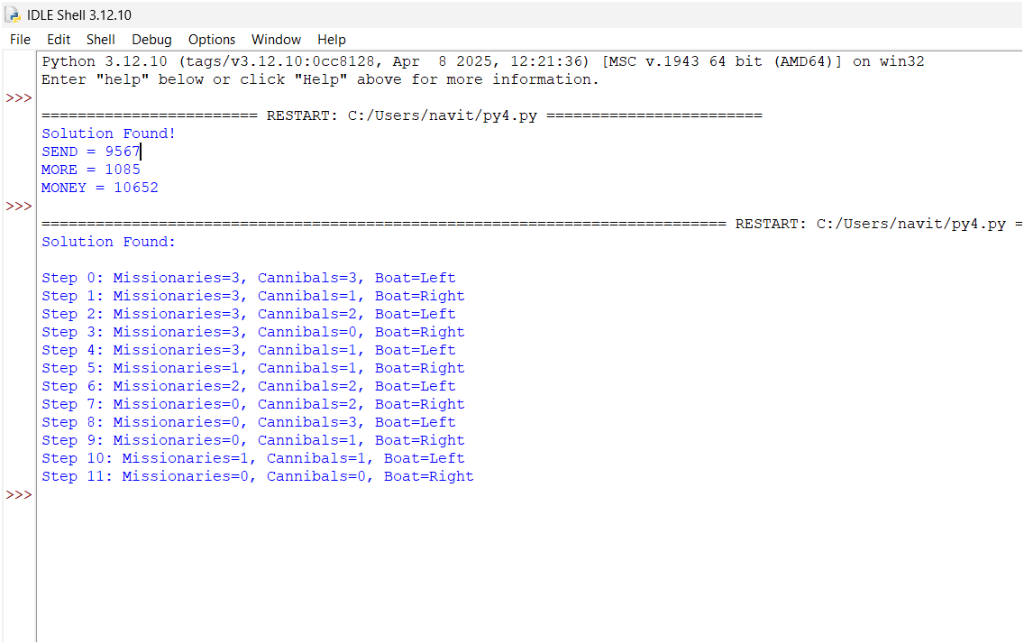
Result:
Thus, the Python program solves the Missionaries and Cannibals Problem using BFS while ensuring that missionaries are never outnumbered by cannibals on either bank when missionaries are present.

